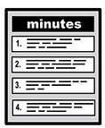 | Carers Reference Group  14th April 2023
 | The people who came  - Lynn Bailey  - Madeleine Fahy – Connect in the North/Through the Maze  - Maire Sykes  - Kausar Iqbal  - Jackie Hartley  - Maureen Lumb  - Nicky Lines – Pyramid 100% Digital Leeds
 | Apologies  - Suzanne Jackson-Bailey  - Shirley Evison  - Yvonne Ugarte
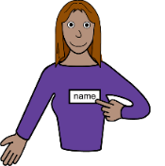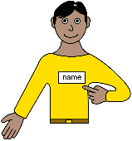 | Introductions  Lynn opened the meeting everyone introduced themselves Lynn went on to introduce Nicky.
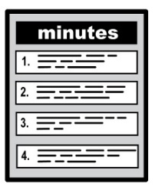 | Minutes from last meeting  Everyone agreed that the minutes from the last meeting were correct.
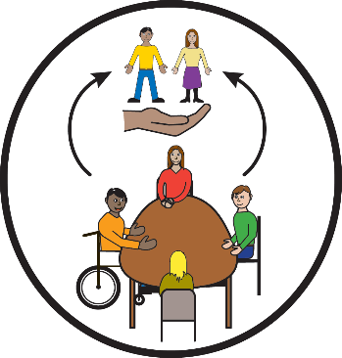 | Promotion of The Carers Reference Group  Lynn spoke about 2 new family carers wanting to join the group. It was felt that more people should know about the group and the work that it does and has done. It was reminded that numbers need to be monitored as too many people would cause complications with room bookings etc.
   | Nicky Lines – Autism & Learning Disabilities Digital Inclusion Coordinator Leeds  Nicky spoke about the work she is doing across Leeds and will send a separate document outlining all the organisations and apps that are available to help with technology and getting on line.  Nicky spoke about Dragon software that could be helpful for people who couldn’t read or write.  The group discussed about the barriers people have for getting on line, some of them were costs, danger of being on the internet, lack of help therefore leading to frustration and bad temper. Nicky agreed with all of these and gave some great suggestions all of which will be on a separate sheet. Nicky also invited the carers to attend the ALaDDIN group meetings which are regular digital inclusion meetings held on zoom.
  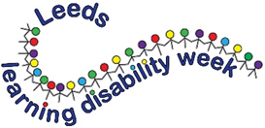 | Leeds Partnership Board – 18th April 2023 – Being Connected  Being Social  The Carers are meeting at The Sugarmill, Office 46, to attend the hybrid meeting on Zoom  Madeleine spoke about the agenda for the Being Social themed meeting.  Leeds Learning Disability Week 2023  How do people make friends?  What is happening in your area. Mapping activities that people can join in.
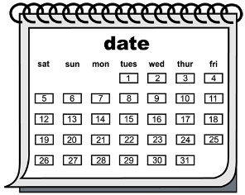 | Date and time of next meeting –  10am drinks for 10.30am – 12.30p  Friday 30th June 2023.

