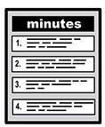 | Carers Reference Group  30th June 2023
 | The people who came  - Madeleine Fahy – Connect in the North/Through the Maze  - Maire Sykes  - Kausar Iqbal  - Suzanne Jackson-Bailey  - Shirley Evison  - Yvonne Ugarte  - Nicky Lines – Pyramid 100% Digital Leeds  - Julie Royle – Evatt – LYPFT  - Alice James – Pyramid 100% Digital Leeds  - Anne-Marie Barrel - LYPFT
 | Apologies  - Lynn Bailey  - Jackie Hartley
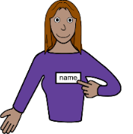 | Introductions  Kausar opened the meeting everyone introduced themselves. During the introductions Julie spoke about the Primary Care Network (PCN) changes and how more than one GP practice will be forming a cluster as different practices have different specialisms.
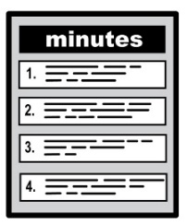 | Minutes from last meeting  Everyone agreed that the minutes from the last meeting were correct.
 | Madeleine spoke about Leeds Learning Disability awareness week. Madeleine showed the group the report from the Being Social Market Place Event. (please see separate attachment). It was noted that the march from the Civic Hall to the market was extremely wet but it did raise some awareness with bus drivers who hooted their horns etc. Hopefully bigger and better next year.
 | Leeds Partnership Board – 13th July 2023 – Being Employed  The Carers are all welcome to meet at The Sugarmill, Office 46, to attend the meeting on Zoom at 10am.  Madeleine is hoping to get an agenda asap. In the meantime, Nicky asked to share the employment video that has recently been made. Please click on the link below to view the video.  Employment Video
 | Get Checked Out Leeds Website  Julie and Anne-Marie spoke about the importance of Annual Health Checks for people with learning disabilities. Julie went into detail about what should happen at an Annual Health Check and how long it should be. Anne-Marie shared the booklet (which can be found on the website above) this is a really useful document that can be completed before the appointment and can also help with knowing what kind of questions the doctor or nurse will be asking.  Annual Health Check Video  Madeleine can print some off if anyone would prefer a paper copy.  Madeleine@citn.org.uk 0113 2703233  Julie also asked if family carers had any problems with their GP’s to let her know and they can contact the surgery on their behalf. Julie and Anne-Marie would also like to hear from family carers if they have anything they would like to share with regards to health matters.  If anyone has any concerns please contact her.  julie.royle-evatt@nhs.net
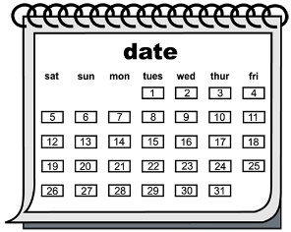 | Date and time of next meeting –  10am drinks for 10.30am – 12.30pm  Friday – 29th September 2023

