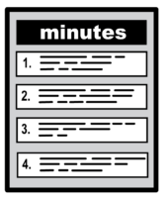 | Learning Disability Partnership Board – Being Well  Tuesday 17th October 2023  10am – 12noon at Hillside  Minutes | 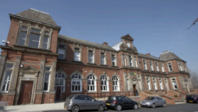
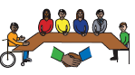 | Welcome and introductions – from the co-Chairs Councillor Sharon Burke and Em Pearson
Agreeing the minutes from the last LDPB on 7 September 2023

The minutes were accepted as true account
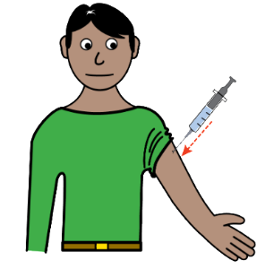  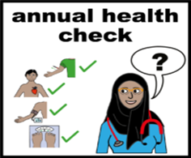 | Winter Vaccinations and Annual Health Checks  A presentation was given by Julie Royal-Evatt from the Health Facilitation Team at LYPFT (Leeds and York Partnership NHS Foundation Trust).  The presentation looked at getting ready for winter and what people can do.  - If you have not been invited by your GP, please contact them to book in for your annual health check.  - The annual health check should take around 30 minutes and should include a full head to toe examination.  - People were advised of the importance of keeping Covid and Flu vaccines updated.  - Winter vaccinations can be booked online.  - ‘Get checked out Checklist’ booklets were shared at the meeting; these are to help you prepare for the appointment. Get-Check-Out-Checklist-2021-2022-july-1.pdf (learningdisabilityservice-leeds.nhs.uk) 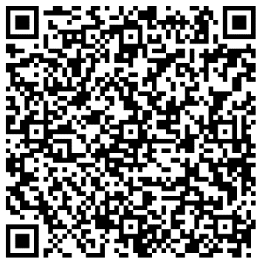  - When at your annual health check appointment, you can use the completed ‘Get checked out Checklist’ booklet to make sure you have discussed everything you wanted to.  - If you have any issues with making appointments or accessing the right care, contact LYPFT (Leeds and York Partnership NHS Foundation Trust) pals.lypft@nhs.net / 0113 8555000  - A reasonable adjustments form was handed out at the meeting. This form will explain to health care providers any difficulties you may have attending appointments and what can be done to make things easier for you. The information is then added onto your medical notes and will immediately flag up when you are referred or present for any medical appointments. Reasonable-Adjustment-Alert.pdf (learningdisabilityservice-leeds.nhs.uk) 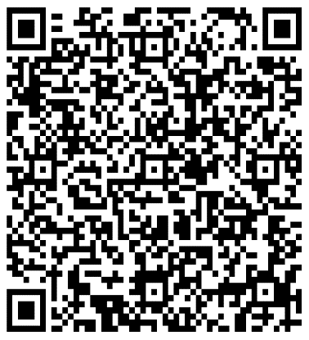  - It was confirmed that the LYPFT (Leeds and York Partnership NHS Foundation Trust) has three experts by experience employed within the trust.  - People felt the waiting periods for appointments were very long.  - It was noted that as some medical problems are not classed as urgent by the GP, but that you can get advice from a pharmacist first, they may still advise you to contact your GP.  Q. Transport get requests to take people for appointments, what are plans to support this?  A. Each GP practice has social prescribers who are trained to support people with Learning Disabilities. You can ask for them to get involved in supporting your transport needs.  Q. Some GPs are not offering covid vaccines – why?  It is up to each GP surgery what they offer.  Lots of pharmacies are providing winter vaccines. You can follow this link to Book, cancel or change a COVID-19 vaccination appointment - NHS (www.nhs.uk)  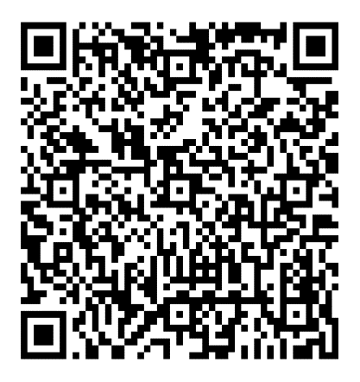  It was also noted that the shingles vaccine is available for people who are over 65 years old.
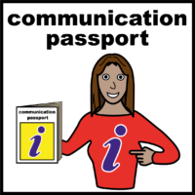 | Health Passports and other adjustments  A presentation was given by Kathleen Smith from the Learning Disability and Autism Team at LTHT (Leeds Teaching Hospitals Trust).  Health Passports are used to help medical professionals get to know you better.  It asks about your likes, dislikes, what healthcare providers need to know to help support people better.  Once complete you can send a photo of the passport by email to leeds-tr.ldautism@nhs.net or you can post the form to:  Learning Disability & Autism Team  2nd Floor, Trust Headquarters  St James's University Hospital  Beckett Street  Leeds  LS9 7TF  - The form will then be added onto the electronic notes held by the hospital.  - This information is kept confidential and only accessed by health professionals that are looking after you.  - When a patient arrives at hospital, an electronic alert is sent to the Learning Disabilities team who will follow up and offer any other support during your stay.  - Passports should be reviewed every year along with your annual health check and update (or more often as needed).  - A hospital passport is not yet available to complete online – but plans are underway to develop this.  Q. How are we getting information about hospital passports out to the wider population?  Information is available on the Through the Maze website: Home - Through the Maze (through-the-maze.org.uk)  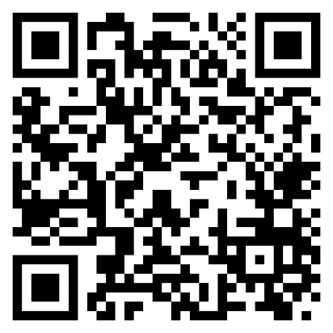  The Working Age Adults Commissioning team at Leeds City Council can send information out to all Leeds commissioned providers, as well as address this through annual performance monitoring checks.  Q. Can the link to a person's hospital passport be added to the ICE contact on people mobile phone? This will be looked into.
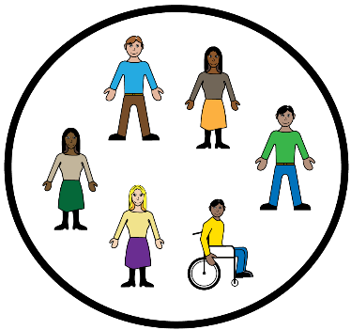 | Learning from Lives and Deaths (LeDeR)  A presentation was given by Audrey Okyere-Fosu from the L West Yorkshire Integrated Care Board.  The presentation looked at the life expectancy of people with learning disabilities, this was recorded in last year's report at 62 years old.  Top 5 causes of death were recorded as  - Aspiration  - Chest infections  - Covid 19  - Heart disease and failure  - Gastrointestinal conditions and sepsis  Two public engagement events held this year which helped to raise awareness. Feedback from the events included:  - People wanted to talk about dying well and making decisions.  - People wanted to know more about LeDeR and how to get involved.  - How can we stop people dying too young.  - How people with learning disabilities can be supported better when talking about dying and bereavement.  - What other support is available.  - People enjoyed the day and said it was not too depressing.  We would like to ask people if they would want a regular talk at learning disabilities partnership board meetings?  Or  Set up local drop-in sessions?  Please send responses to - learningdisabilitypartnershipboard@leeds.gov.uk
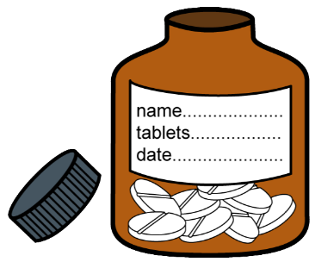 | Bigger Better Labels Update  The presenter was unavailable on the day so this agenda point will be moved to the next Learning Disability Partnership Board meeting.
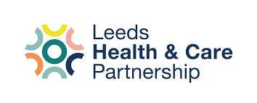 | Learning Disability and Neurodiversity Board Engagement  A presentation was given by Adam Stewart the Senior Insight, Involvement and Engagement Advisor from NHS LEEDS Intergrated Care Board?  Adams job is to make sure that people who use health services have a say in how services work.  Leeds is changing how it plans and provides care.  Now looking at ‘Populations’ This means groups of people who share something that relates to their health:  - People with a learning disability  - People with a mental health condition  - People with cancer  - People using maternity services  - Children and young people.  Each population has its own board.  The Learning Disability and Neurodiversity Population Board represents people from the 'population' with a learning disability or who are neurodivergent. This means the board represents you if you:  - Have a learning disability  - Are Autistic  - Have ADHD / ADD.  The boards need people to be involved and to help decide:  - How to spend money  - When to make changes  - What is most important?  - How to get best value for money.  The discussion points included:  - If payments are made for involvement on a board as an expert by experience, it can impact on benefits.  - The importance of having a few experts by experience on each board, as if there is only one representative they could feel under pressure.  - People will not come if they are not valued.  - If people are not paid in money or vouchers, there is no incentive to give their time.
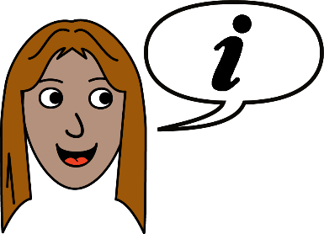 | Any Other Business  Connect in the North confirmed they had spaces on their upcoming bereavement course – details would be circulated to the learning disability partnership board mailing list.  Due to the number of speakers and information included on the agenda, it was proposed by the chairs that we look at limiting the number of speakers at each meeting. It was agreed this would be discussed at the next Theme lead meeting in preparation for the next learning Disability partnership Board in January.

