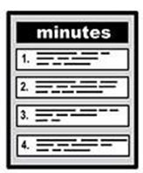 |   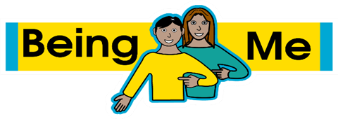  Being Safe Task Group  Thursday 26th February 2026  10:30am – 12:30pm  Minutes of the meeting
 | The people who came  - Chris Charlton (CC) (Aspire) – Chair  - Cath Lee (CL) (Aspire) - Chair  - Councillor Kevin Ritchie (KR)(LCC elected member)  - Becks Wheatley (BW) (Next Gen Leaders)  - Imogen Day (ID) (Asking You!)  - Oliver (Asking You!)  - Courtney (Asking You!)  - Madeleine Fahy – Connect in the North/Through the Maze  - Caroline Armstrong (LCC Working Age Adults)
 | Apologies  - Mahreen Hussain (WY Police, Leeds Community Cohesion Seargeant) MH had now changed roles  - Stella Chan (WYCA) SC has now changed roles  - Leah Burch (Liverpool Hope University)  - Claire Nixson – Forum Central  - Zoe Bawn (Aspire CBS)  - Alex Toothill (Advonet)  - Sarah Wheatley (CiTN)  - Richard Cotton (West Yorkshire Police – Safer Travel Sargeant)  - Lucy Wild (West Yorkshire Combined Authority – Safer Travel Officer)  - Tania Woodhouse (TW) (Connect in the North)  - Lynsey Howarth (LH) (People Matters)  - Dominique Burley (DB) (Forum Central)  - David Crake (DC) (LCC Transport)  - Beth MacDonald (BMc) (Advonet)  - Rita Rani (Yorkshire Ambulance Service NHS Trust)
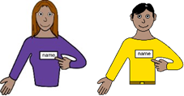 | Welcome and introductions  CC welcomed everyone to the meeting and everyone introduced themselves.
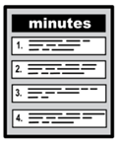 | Agreeing the minutes from the last meeting  Everyone who was at the last meeting agreed that the minutes were accurate.
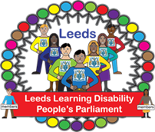 | Learning Disability People’s Parliament  ID fed back from the most recent People’s Parliament. The group have now changed how the meetings are run with all of the Being Me Strategy themes being considered at each meeting. The dates of meetings for the year are on the Asking You website.  The group have now set up a Whatsapp group which is very popular.  ID explained that Asking You! Is now the umbrella brand for all the learning disability services that Advonet run.  ID explained that unfortunately Change is closing. There is more detail about this on the website.  Cllr Ritchie fed back that the experience shared by one member of the group about the experience they had when they needed to call the police was encouraging. The police had been responsive and supportive.  ID shared that Asking You! Are running some training for new volunteers.  CC asked how the meeting had gone. ID said it had gone well except one of the speakers had not been able to attend. They will arrange back up speakers in the future.  ID explained that she and Courtney will be speaking at the Learning Disability England online conference on March 11th with BeMix. They will be talking about inclusive recruitment and employment practices. ID encouraged the members of the group to attend the conference. The Conference 2026 - Learning Disability England.  BW is keen to link up with ID and Asking You in relation to inclusive recruitment. BW will contact ID.
  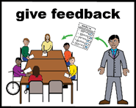 | Feedback from the Learning Disability Partnership Board meeting – focus on Being Employed  CL and ID fed back from the meeting. The notes will be circulated when they have been produced.  Advonet/Asking You had talked about their inclusive recruitment work and also their sexual harassment workshop.  The LDPB also heard about Nourishing People which is a social enterprise run by people with learning disabilities and supported by People Matters.  The group talked about Access to Work and the average wait time to be able to access required support.  Ellen Barnes and Jenny Hamer from the Health Facilitation team talked about the National Patient Safety Improvement Programme which is investigating the use of psychotropic medication and patients’ experiences. They are interested in understanding any barriers and challenges to this medication being managed safely eg. review meetings.  Under AOB Cllr McClusky let everyone know that he has written to Tracey Brabin in relation to the start time of bus passes highlighting the impact of this on people being able to work.  CL advised the group that the next LDPB meeting will be on May 12th and it will be held at Hillside.
 | Partner updates  Advonet – the group have set up a whatsapp group. ID will email the link if anyone is interested in joining.  ID mentioned that some of the services that the Good Lives Leaders have contacted are not responding and so they haven’t been able to complete visits. Connect in the North shared that they have been able to complete 6 visits. Asking You are offering personal safety workshops which includes night safety.  Cllr Ritchie - KR let the group know that William Merritt Centre are hosting a Gameblast fundraising event on 27th February. There will be an opportunity to drop in for tea and cake to support the event at 4pm. Everyone was encouraged to go.  Bright Sparks – CC updated the group about the Real Friends performances that have been taking place in schools. They have been very well received. CC reminded the group that there will be an open performance on March 31st. The flyer with full details will be re-circulated.  MF mentioned that they had booked 8 tickets but hadn’t heard anything. CL to forward the query to Bright Sparks.
 | Any Other Business  MF informed the group that Thomas Chalk is on long term sick and will not be back at work this year. The group asked MF to pass on their good wishes to TC when she is next in touch. TC is a valued member of the group and we wish him a successful recovery. In TC’s absence MF will attend the meeting and she and Sarah Wheatley will be covering TC’s work.  CL informed the group that Mahreen Hussain from WY police has moved into a different role. There is no replacement for her currently but CL will make contact with MH’s superior to find out whether the involvement and use of the police station to run joint events will be able to continue.  CL informed the group that Stella Chan has moved to a different role and has passed on a contact for us if we are working on issues relating to the transition age group.  ID suggested that the task group could run a separate event if needed and suggested that they might be able to use the meeting room at Advonet although there may be restrictions on when it could be used.  MF let people know that the Being Social event during Learning Disability Week will take place again and will be on Tuesday 16th June. Anyone who wants to book a stall should contact Sarah Wheatley.
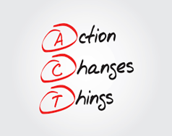 | Next steps/actions  - BW to contact ID re. inclusive recruitment  - CL to recirculate Bright Sparks Real Friends performance flyer  - CL to chase status of tickets on behalf of CiTN
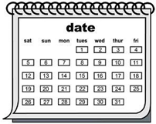 | Future Meeting Dates  All dates have been put in the calendar and are attached.  The next meeting is on Thursday 4th June at Hillside Enterprise Centre, Beeston Rd, Holbeck, Leeds LS11 8ND from 10.30am to 12.30pm  Future dates for 2026-2027 were circulated. The group revisited whether to have more in person meetings but concluded the challenges of finding and funding a venue might be a barrier to this.  CL suggested inviting Neena Punnu (Senior Policy & Performance Officer – Equality & Hate Crime in the Safer and Stronger Communities team) to the next meeting to talk about their work  The group agreed.

